

SC4015 Cyber Physical System Security
Side-Channel Analysis Project Report
AY25/26 S2

Name | Matriculation Number
Gokul Ramesh | U2222182H
Cornelius Ang Cheong Fei | U2322223D
Jonathan Low Seng Kian | U2321652C
Koh Junyang Nicholas | U2222992D

1. Introduction
This report describes the implementation of a Correlation Power Analysis (CPA) attack on an AES-128 block cipher. The objective was to recover all 16 bytes of the secret encryption key using power consumption measurements captured during encryption operations, stored in the provided waveform.csv file.
CPA is a side-channel attack that exploits the physical fact that a microcontroller's power consumption correlates with the Hamming Weight of intermediate values it processes. By modelling this relationship and comparing it against real power traces, the correct key can be identified statistically without needing to mathematically invert AES.

2. Implementation Overview
The implementation uses the provided cpa_implementation.py, replacing the simulated trace generation with the real power trace data from waveform.csv. The attack was implemented in Python using NumPy, SciPy, and Matplotlib.

2.1 Data Loading
The waveform.csv file contains 110 rows, each representing one AES encryption operation. Column 0 holds the 16-byte plaintext as a 32-character hexadecimal string, column 1 holds the corresponding ciphertext, and columns 2 onwards contain 2500 floating-point power samples captured by the oscilloscope. The 110 rows were used for the attack. Each hex string was parsed into a list of 16 integer bytes, and power readings were loaded into a NumPy array of shape (110, 2500).

2.2 Power Model Matrix Construction
For each of the 16 AES key byte positions, a power model matrix M of shape (256, 110) was constructed. For every possible key byte guess k (0x00 to 0xFF) and every trace t, the hypothetical power consumption was modelled as:
M[k][t] = HW( SBOX( plaintext[t][byte_index] XOR k ) )
where HW denotes the Hamming Weight (number of 1-bits) of the byte, and SBOX is the standard AES SubBytes lookup table. This models the first operation performed by AES, the AddRoundKey XOR followed by the SubBytes substitution, which is the point at which power leakage is targeted.

2.3 Correlation Matrix Computation
Each row of M (a vector of 110 predicted Hamming Weights for a given key guess) was correlated against every column of the real power trace matrix T of shape (110, 2500) using the Pearson correlation coefficient. This produced a correlation matrix C of shape (256, 2500), where C[k][s] represents how well key guess k explains the power variation at time sample s.

2.4 Key Byte Recovery
For each key guess k, the maximum absolute correlation value across all 2500 time samples was extracted from row k of C. The key guess with the highest peak was identified as the correct key byte. This process was repeated independently for all 16 byte positions, recovering the full 128-bit key.

2.5 Key Verification
Additionally, after the key was recovered, we used the ciphertexts provided in waveform.csv to check that our recovered key was correct. We randomly chose 20 plaintexts, and encrypted it using AES with our recovered key, then checked that the output matched with the ground truth ciphertexts.

3. Experimental Results

3.1 Recovered Key
Running the CPA attack on 110 traces from waveform.csv successfully recovered all 16 bytes of the AES-128 secret key:
48 9D B4 B3 F3 17 29 61 CC 2B CB 4E D2 E2 8E B7
The correlation peaks for each byte ranged from 0.49 to 0.70, indicating strong statistical separation between the correct key guess and all other candidates across all 16 positions.

3.2 Key Verification Result
Running the verification script produced the following output:

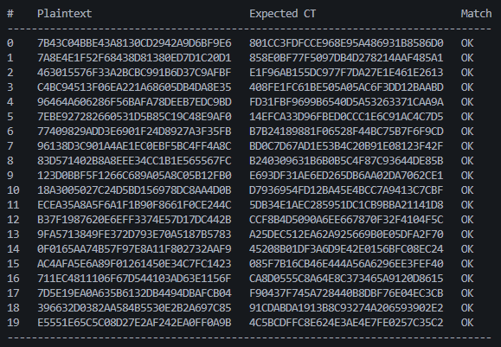

3.3 Plots for all Key Bytes

Here are all 16 plots for the correlations across all the data for every possible value of the key. They are ordered from byte 0 onwards:

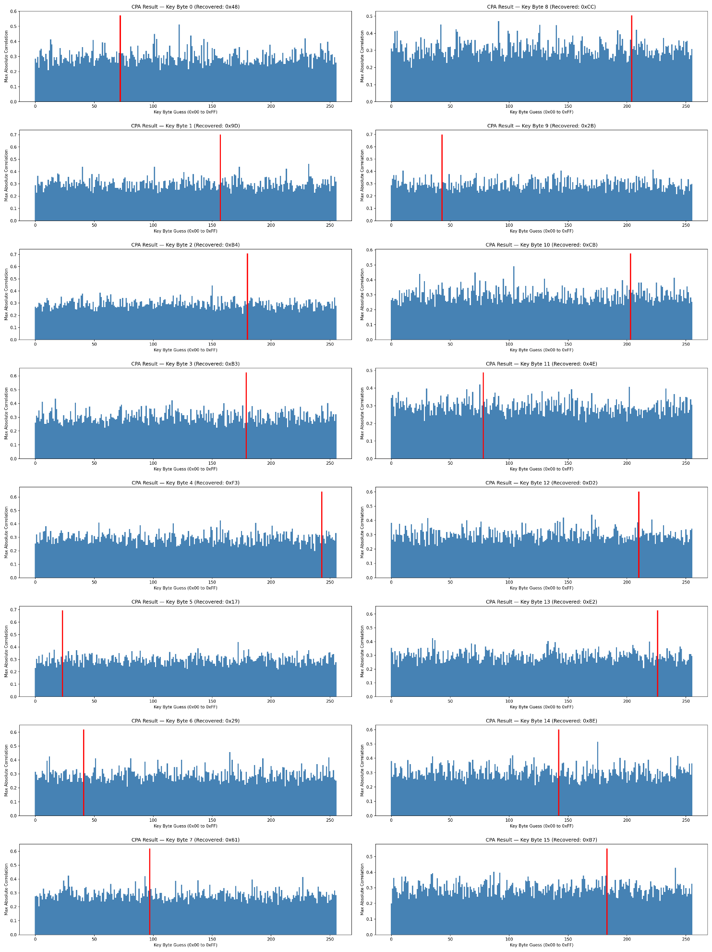

4. Conclusion

In summary, this work has successfully proven the ability of CPA (correlation power analysis) to attack the AES128 encryption algorithm due to its physical side-channel leakage. The CPA has been able to statistically isolate 16 bytes of the 128-bit secret key using the hamming weight power model and Pearson correlation coefficient, through all the power traces collected. Notably, the attack on the full 128-bit key failed when using only 100 traces due to a lower Signal-to-Noise Ratio (SNR). However, increasing the data set to all 110 traces improved the SNR sufficiently to achieve a 100% success rate in key recovery. These results further emphasize the need for the implementation and use of hardware-level countermeasures, such as masking or hiding, to protect embedded systems against side-channel attacks.

